DOCUMENT 1
PROJECT CHARTER & STRATEGIC PLANNING

STREAMLINING TICKET ASSIGNMENT FOR EFFICIENT
SUPPORT OPERATIONS
Executive Summary
As ABC Corporation is a leading technology firm, it recently faced significant bottlenecks in routing support tickets to the correct teams. This project leverages the ServiceNow platform to transform manual ticket routing into an automated process, thereby increasing operational efficiency. This initiative ensures faster issue resolution and strengthens customer trust in our support services.

Problem Statement
The primary issues encountered in the manual ticket assignment process were:
- High Latency: There was a significant lead time between ticket creation and its arrival at the correct support team.
- Human Error: Due to manual intervention, tickets were frequently assigned to the wrong groups.
- Scalability: Managing the increasing volume of tickets manually became difficult as the organization grew.
- Inefficiency: Support agents wasted valuable time manually searching for tickets relevant to their expertise.

Goals & Objectives
- Response Time Reduction: To reduce the average ticket response time by 40%.
- Accuracy: To achieve 100% precision in routing tickets to the correct assignment groups (Platform/Certificates).
- User Productivity: To optimize support agents' working hours, allowing them to focus on resolving tickets quickly.
- SLA Compliance: To ensure all tickets are completed without delays, in accordance with the Service Level Agreement.

Project Scope
The scope of this ServiceNow configuration project includes:
- User Identity: Creation of new users, specifically Manne Niranjan and Katherine Pierce.
- Group Hierarchy: Configuration of 'Platform' and 'Certificates' assignment groups.
- Data Architecture: Creation of a dedicated custom table named 'Operations related'.
- Security: Implementation of role-based security settings via ACL (Access Control List).
- Automation: Setting up automated triggers and assignment rules using Flow Designer.

Stakeholder Matrix
Stakeholder Role | Responsibilities
Project Manager | Managing the project timeline and budget.
ServiceNow Admin | System configuration, table creation, and flow activation.
Group Managers | Monitoring the performance and efficiency of support teams.
End Users/Clients | Creating support tickets and receiving resolutions.

Technical Requirements
- Platform: ServiceNow (Vancouver or Washington Release).
- Modules: Flow Designer, System Security, System Definition.
- Infrastructure: Minimum 8GB RAM Laptop/Desktop, High-speed Internet (10Mbps+).
- Web Browsers: Google Chrome (Latest), Mozilla Firefox, or Microsoft Edge.
- Authentication: Multi-Factor Authentication (MFA) must be active.

Strategy Phase 1 - User Identity Management
As a first step, providing appropriate access to the right individuals within system security:
- Creating User IDs using a standard naming convention.
- Correctly setting the Time Zone and Date formats (e.g., America/Los Angeles).
- Accurately recording email and department information in user profiles.
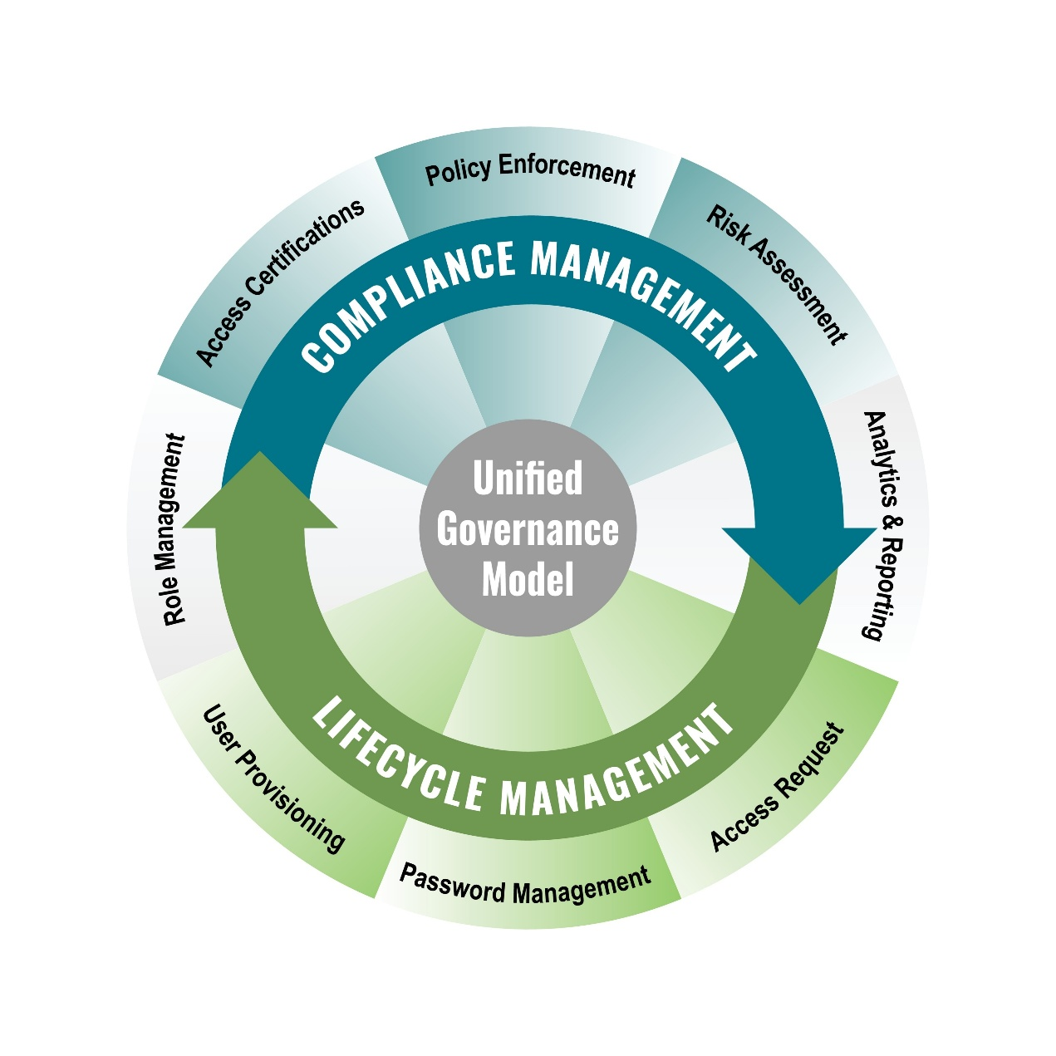
Shutterstock
Explore
Strategy Phase 2 - Group Hierarchy & Escalation
The strategic plan for organizing support teams:
- Group Division: Dividing technical support into two specialized units: 'Platform' and 'Certificates'.
- Manager Assignment: Appointing a dedicated manager for each group to ensure accountability.
- Escalation Matrix: If a ticket is not resolved within the specified timeframe, the system is configured to automatically send an alert to the respective manager.

Data Strategy - Table Structure & Integrity
The core database framework of the system:
- Table Name: u_operations_related.
- Data Integrity: Preventing data duplication through the implementation of a unique 'Service Request Number'.
- Mandatory Fields: Setting 'Assigned to group', 'Priority', and 'Issue' fields as mandatory to ensure complete data capture.
- Choice Lists: Using dropdown menus to prevent incorrect or invalid data entry by users.

Risk Management & Mitigation
Strategies to handle potential project challenges:
- Risk 1: System Downtime – If the ServiceNow instance becomes unavailable, a manual backup system will be kept in a state of readiness.
- Risk 2: Logic Failure – In case of incorrect logic within the Flow Designer, an 'Error Handler' flow will be integrated to monitor and report issues.
- Risk 3: Access Issues – If authorized users cannot access records due to ACL restrictions, the 'Debug Security' rules will be used for immediate resolution.

Success Metrics (KPIs)
To monitor and evaluate the successful implementation of the project:
- ROI (Return on Investment): Savings achieved in manual labor costs through automation.
- CSAT (Customer Satisfaction): Ensuring customer satisfaction ratings remain consistently above 4.5/5.
- MTTR (Mean Time to Resolve): Aiming for a 50% reduction in the average time taken to resolve a ticket.

